


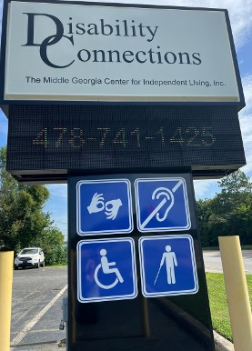

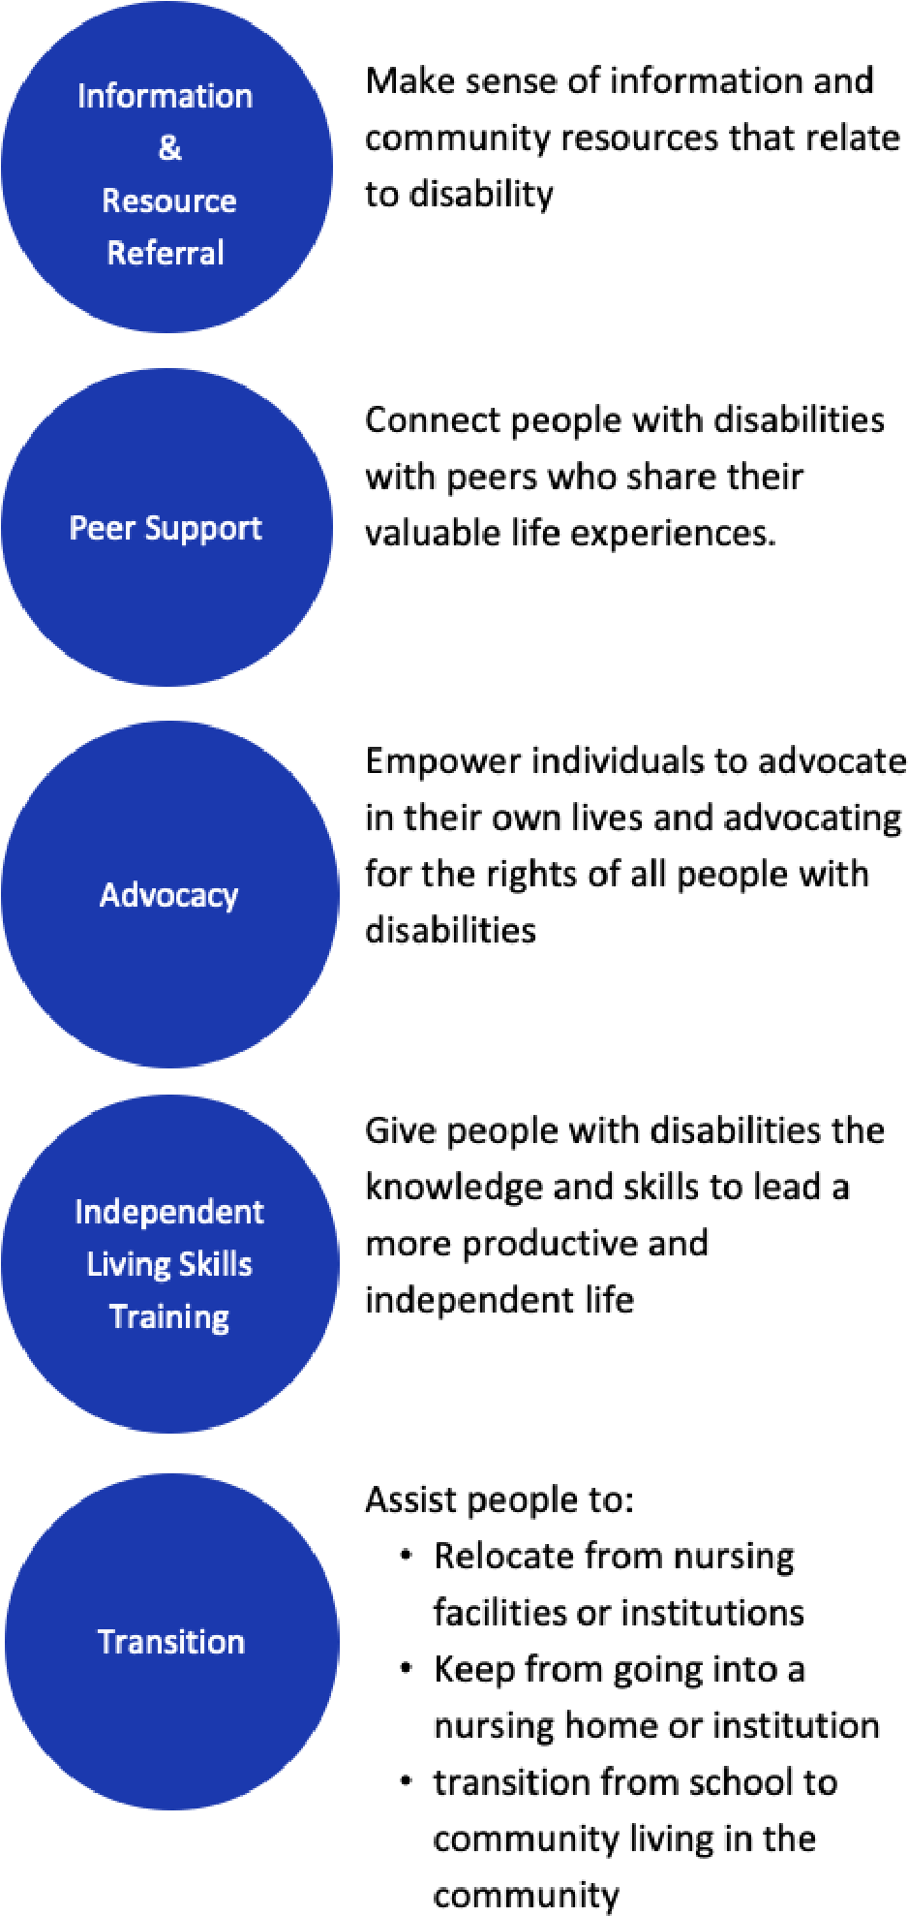

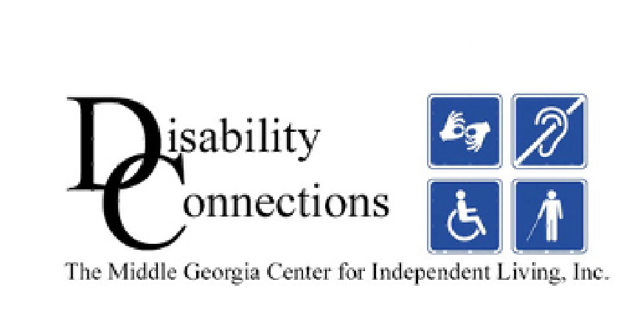


Enabling all people with
disabilities to attain access to all
opportunities in life.
Contact Us:
(478) 741-1425
Our Core Services
MIDDLE GEORGIA CENTER FOR

INDEPENDENT LIVING, INC.
D.B.A. DISABILITY CONNECTIONS
3695
Broadway
Macon, GA 31206

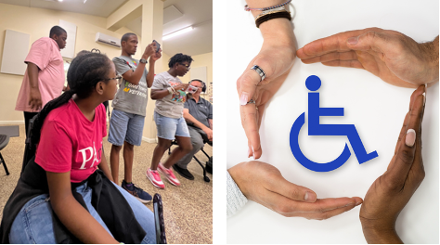



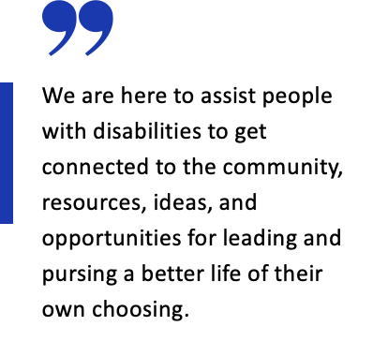
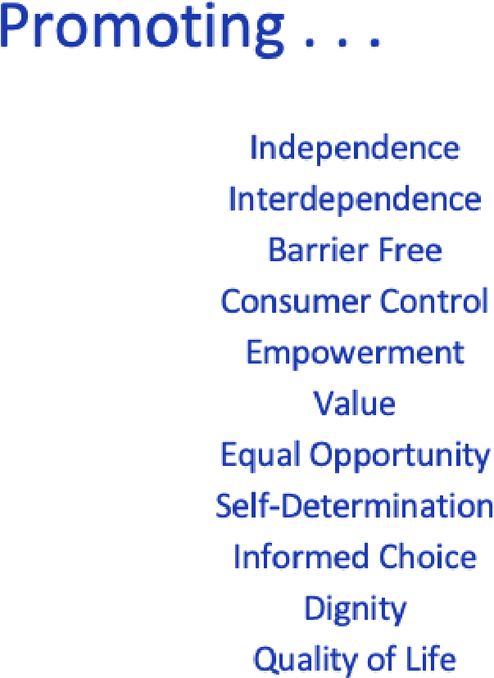
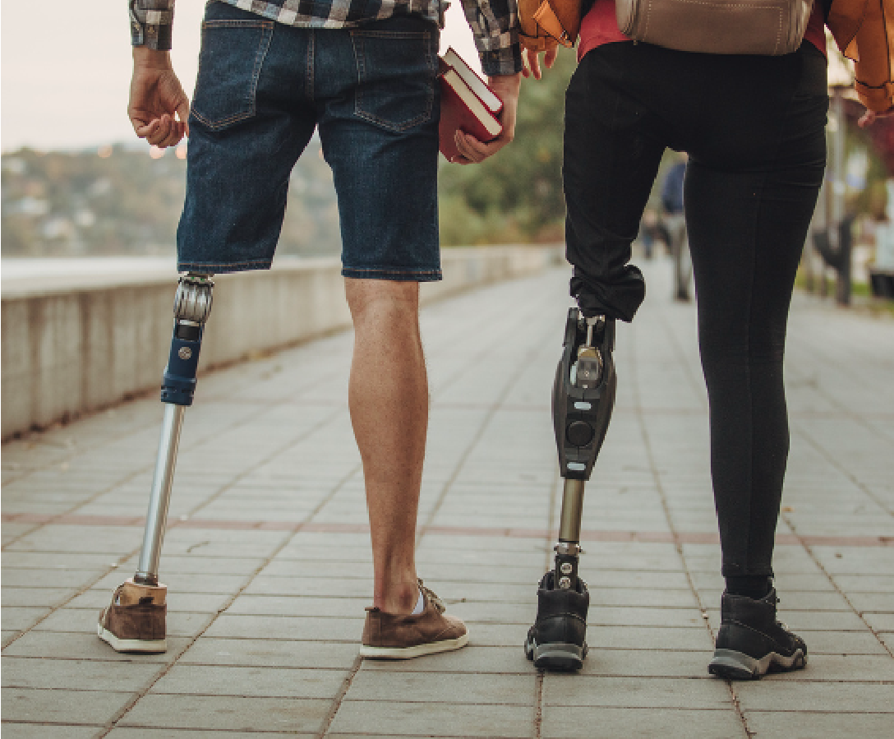

Counties We Serve:
Baldwin

Ben Hill
Bibb

Crawford
Coffee

Dodge
Houston

Irwin
Jasper

Jeff Davis
Jones

Laurens
Monroe

Montgomery
Peach

Pulaski
Putnam

Telfair
Treutlen

Turner
Twiggs.

Wheeler
Wilcox

Wilkinson

